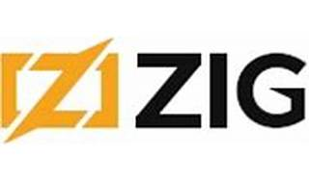



Explore

**Zig** is a **general-purpose programming language** designed for robustness, performance, and simplicity. [It aims to be a successor to C, offering modern features, safety mechanisms, and efficient code execution without hidden complexities1](https://ziglang.org/).

Here are **five free resources** where you can learn more about Zig:

1. [**Zig Official Website**](https://ziglang.org/): The official Zig website provides comprehensive documentation, tutorials, and examples to get you started[1](https://ziglang.org/).
2. [**Zig Wikipedia Page**](https://en.wikipedia.org/wiki/Zig_%28programming_language%29): Explore the language’s background, design goals, and comparisons with C[2](https://en.wikipedia.org/wiki/Zig_%28programming_language%29).
3. [**In-depth Overview**](https://ziglang.org/learn/overview/): Dive into Zig’s small, simple language, performance, safety features, and more[3](https://ziglang.org/learn/overview/).
4. [**Zig Community**](https://ziglang.org/): Connect with other Zig enthusiasts, join discussions, and learn from the decentralized Zig community[1](https://ziglang.org/).
5. [**Zig GitHub Repository**](https://github.com/ziglang/zig): Access the source code, contribute, and explore issues related to Zig development[1](https://ziglang.org/).

Happy learning! 🚀🔍📚